* Write a shell script to accept number from user and print if it is odd number or even number

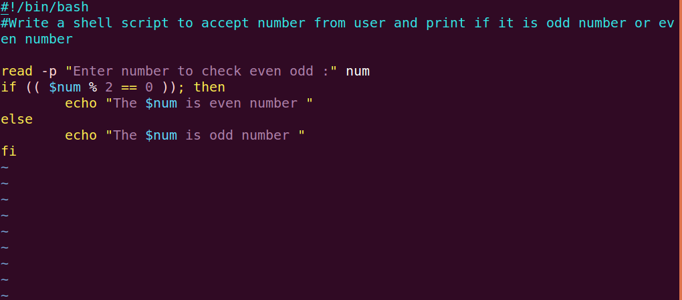

* Write a shell script to find all prime numbers in between 1 to 100.

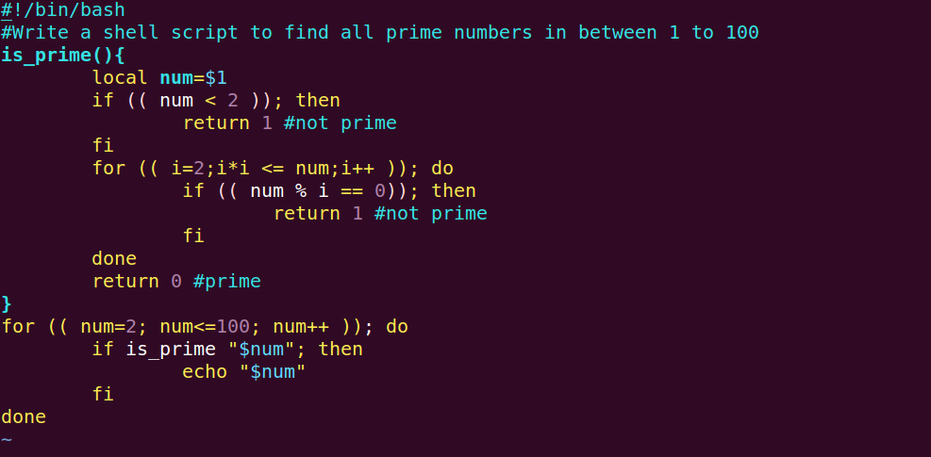

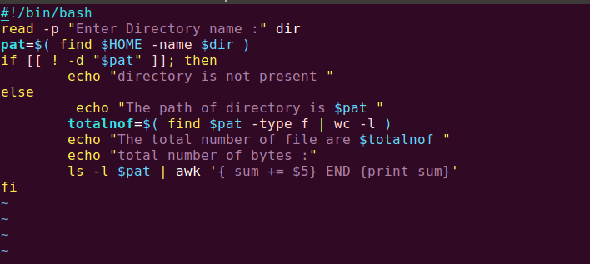

* Write a script that gives menu to run the following:
  + List of active users on the system
  + Process list for the system
  + Accept file name and print permission, owner and group details for the file
  + Date/time when the machine was last rebooted

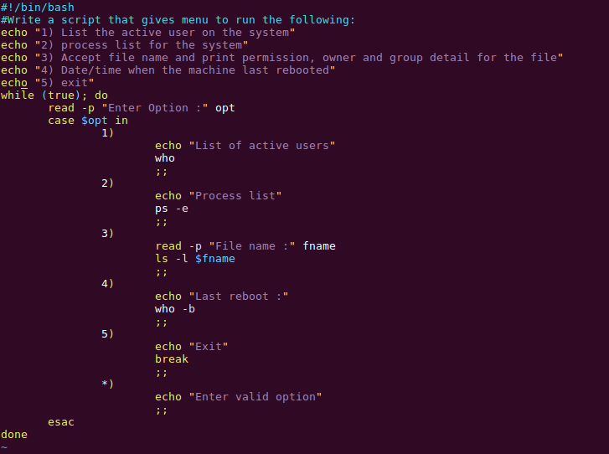

* Write a script that will extract patterns from /var/log/messages file where patterns contain the words
  + Error
  + Failed
  + Down
  + Up
  + Full
  + Unknown
  + Critical
  + Warning

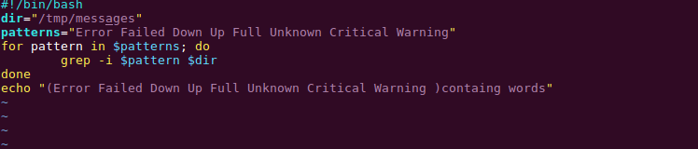

* Write a script that shows the name of the file system that has less than 50% free space. Percentage of free should be a configurable parameter not hardcoded

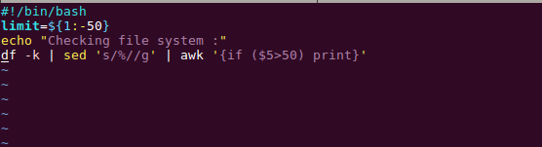

* Write a script that picks-up list of hosts from a file, connects to each of these hosts and run following commands on these hosts
  + Uptime
  + Uname -a

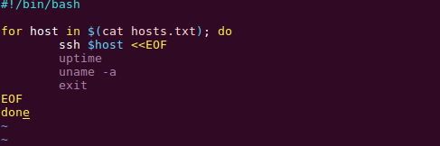

* Write a script that accepts directory name as input and print file name where the file-modification time is older than 15 days

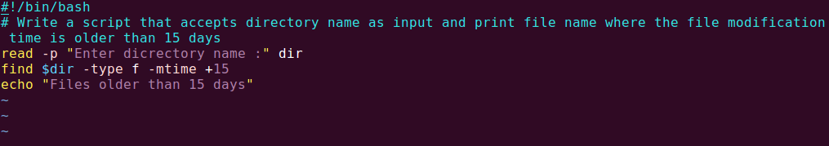

* Write a script that accepts directory name as input and print file name where the file-modification time is lesser than 04 days

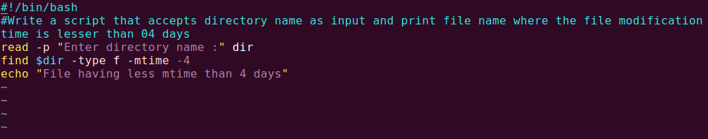

* Write a script that accepts directory name as input and print file name where the size of file is lesser than 100Kb

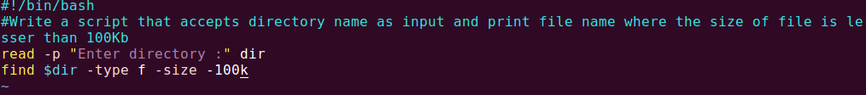

* Write a script that checks if following process are running on the machine.
  + ora_pmon_test
  + tnslsnr
  + cron
  + httpd
  + sshd

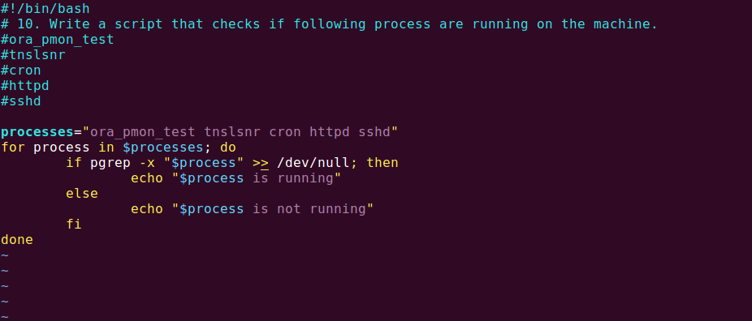

* write a script that accepts a hostname / IP as input and checks if connectivity to that host exists

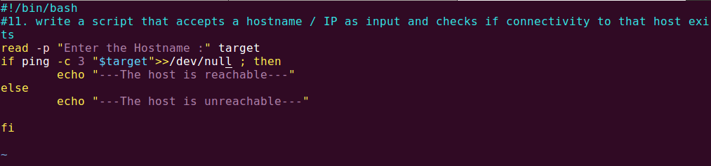

* write a script that accepts a hostname / IP as input and draws the routing table to reach that host.

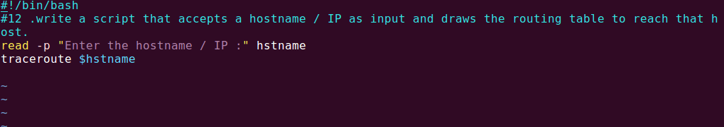

* write a script to find files that have SUID bit set, GUID bit set, Sticky-bit set

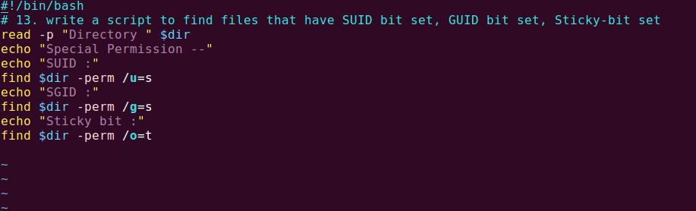

* Accept a date from user. Then using the “last” command, print number of unique pairs of users and the IP’s (from where they have connected to this machine) for the chosen “date”

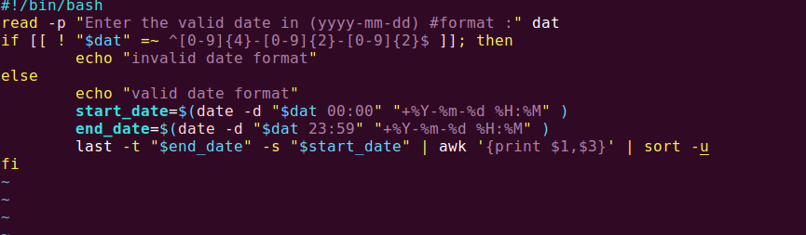

* Write a script that joins alternate lines from two files and saves the output into a new file

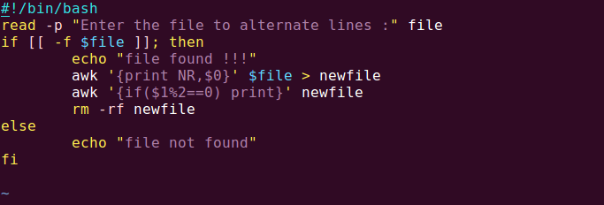

* Write a script that accepts a directory name, then prints
  + Number of files in this directory
  + sum of size of all files in this directory

